Pranit Nadipelli
Period:3
10/16/17
Measuring the Efficiency of a Solar-Tracking System

Problem Statement:
A stationary solar-panel’s efficiency varies with the time of the day, and batteries are used to power the system at night. In order to make solar-panel’s more appealing to individual homeowners and small-businesses the efficiency of solar panels have to optimized. Large scale solar-farms have single-axis and dual-axis tracking systems that follow the sun throughout the day to maximize energy production. However, owners of Micro-grids cannot afford the upfront capital costs of commercial solar trackers. As of right now, the economic benefits of a solar-tracker are less than the costs of a solar-tracker. Therefore, a cheaper system would be required for these parties to see any economic benefit. If a cheap solar-tracker can be made, the energy output of solar microgrids can be optimized.

In several developing countries, rural areas have to rely on a centralized grid system for electricity. These centralized systems attain power from a local power-plant. Energy production is a critical issue in the developing world. Centralized power systems are supply-based endeavors. When there is a high supply of energy, small parties such as farmers will receive their power for the day. However, when there is a shortage of a factor of production such as oil or coal, farmers are the first to be cut off from the power-grid (Kaundinya et.al, 2009). In areas with poor rainfall, this can be a life or death situation. Crops would fail due to a lack of irrigation, resulting in decreased revenues. To combat these problems, rural areas in the developing world should rely on decentralized power systems such as solar panels. However, the power consumption of these small villages is increasing on a large scale. In order to create a sustainable system, Solar trackers can be used to help these rural villages develop.

Objectives:
A Preliminary objective for this research project would be to create a working solar-tracker, and measure the costs associated with building it. The system would also have to be lightweight to maximize energy production. In order for this solar tracker to be economically feasible, a single or dual-axis solar tracker should be compared with a stationary solar panel. Single-axis trackers have a 180-degree range of motion, and are implemented in large-scale solar farms. They can increase the energy-production of a solar panel by approximately 20%(Maehlum, 2013). Dual-axis trackers can move across a hemisphere, and are more efficient than single-axis trackers. The Dual-axis tracker would be ideal; however, its cost is significantly higher than a single-axis tracker and are more complicated in design. They can increase the energy-production of a solar panel by approximately 35% (Maehlum, 2013). Cost benefit analysis that measures energy output, revenue projections, and fixed costs would be the quantitative measure of feasibility for this research project, while qualitatively the solar-tracking system would have to be implementable on a broad scale.

Another objective that should be met by this project is the optimization of the system. Optimization is a necessity for any business operation. In order for this solar-tracking system to be economically feasible for small-scale farmers and micro-grid owners, it’s efficiency must be maximized. Making the system more efficient is crucial, so there is a significant economic incentive to implement this Solar-tracker system.

Approach:
With the time available, a single-axis solar tracker would be feasible for this project. There are several DIY projects available for reference on the internet. This research project would serve mainly as a proof-of-concept. Due to a limited budget, I will create a small system for the purpose of research. This solar tracker would consist of a reflective frame to hold the solar panel and reflect light off of the surface of the frame to optimize energy production. The solar panel would be mounted to the frame through the use either vex pieces or 3-D printed material to fit the solar-panel. The vex pieces or 3-D printed material would be connected to motors that are geared for torque in order to support the weight of the solar panel.

There are different types of solar-trackers that are being implemented in the energy industry. This project will focus on two types in particular in order to find the most efficient type of solar-tracking system with budgeted time. Active and pre-programmed solar-trackers are two popular option for large-scale solar farms. Active solar-tracking systems move to the area with the most light using multiple light sensors. Pre-programmed solar-trackers have their movements hard coded into the system and follow a timer.

Pre-programmed solar-trackers generally use GPS chips to find the position of the sun at their current location and track the sun according to their current position throughout the day. In this scenario, the GPS chip would determine the approximate location of the solar panel and serve as the input sensor. It would input the position data of the sun to the Arduino which would determine how to track the sun. The output of the Arduino would be to the motor’s which would slowly move the solar-panel throughout the day. This system would be connected to a battery to measure the amount of energy production.

Active solar trackers use a plethora of light-sensors to find the area within the range of motion that has the most-light. The light sensors of the system would work continuously to find and fine-tune the position of the solar-tracker throughout the day. This system accounts for more variables to fine-tune the position of the solar-tracker, and will result in increased efficiency. Schematically the light sensors would serve as an analog input to an Arduino. The Arduino would read the data and relay information to the motors which would move the solar-panel to the optimal position for energy production. This system would also be connected to a battery to measure its efficiency.

If time allows, the single-axis system can be further optimized if the GPS and Active tracker systems are combined. The GPS system would limit the search area of the light sensors which would conserve time and energy, and then the light sensors would find the optimal position within that area. In many developing areas, satellite signals are poor, so a pure active tracker system would be defaulted to in this case. The light sensors and GPS would serve as the input to the Arduino. The Arduino would calculate the exact position and relay the information to the motors.

Once all these steps are completed I would have to scale my cost calculations and my energy calculations for the typical microgrids system to provide a clear picture of the cost-benefit analysis.

Materials:
Item/Description | Cost
Solar Panel  Small 100 watt solar panel 3in x 28in x 42 in | $98.65
Photo resistors  Can be used as light sensor | tbd
Sparkfun (PID 14030) Mini GPS shield  For the pre-programmed tracker | $12.95
Arduino UNO  The computer for the entire system | $27.95
VEX Motors  Used to move the system | tbd
Gears  Used to create a torque ratio to support the weight of the solar panel. | tbd
Reflective Material  Optimize light intake to boost energy production | tbd
Battery  Measure the energy output of the system | tbd
The ideal system I would like to get to would be a pole-like structure with two joints. It could run on a few motors to move one arm that is attached to another pole which is mounted into the ground. This system is similar to what large-scale solar farms have. I am still working on the CADD Design, so here is a rough sketch.
Sketch:

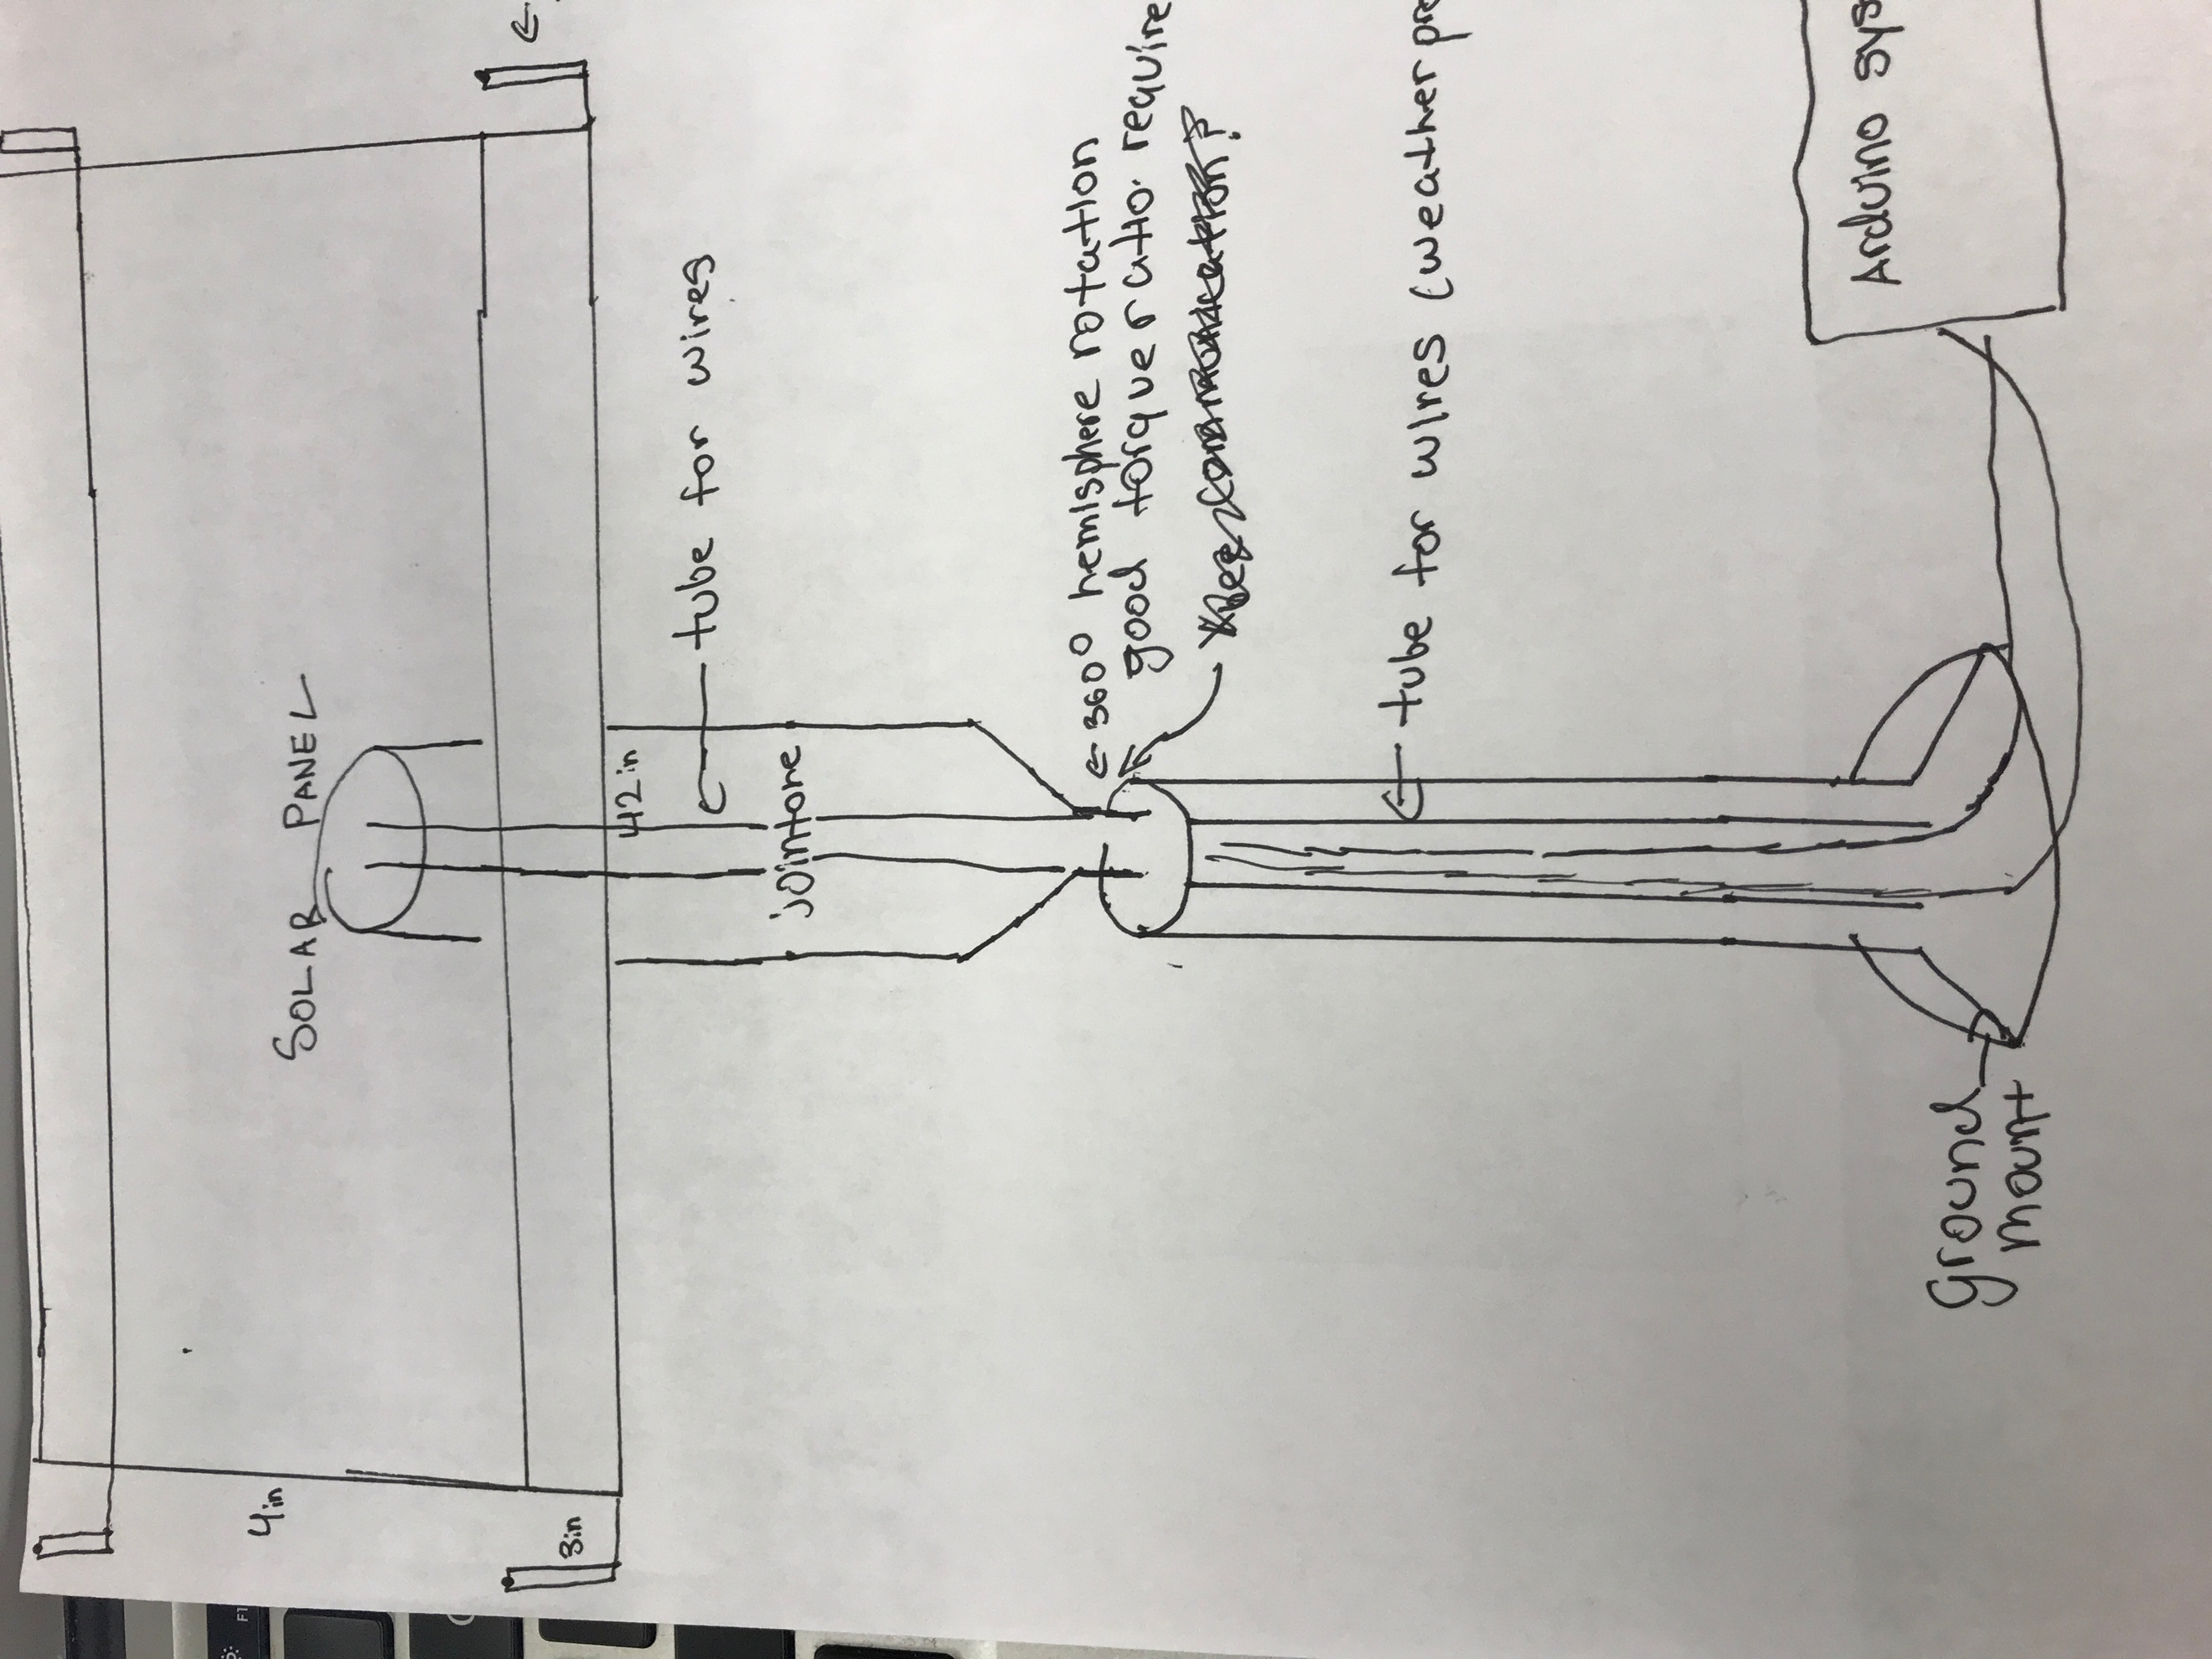

Timetable:
October 23 – November 3
- Finish the CADD Design/Eagle Schematics
- Fill out purchase orders
November 7 – Thanksgiving
- Build the structure with the materials
- Incorporate the motors
- Test whether the gear-structure will hold the weight
Thanksgiving – Winter Break
- Incorporate the light-sensor and GPS into the design
- Use Arduino to code the Pre-Programmed and Active Tracker systems
- Test the functionality of the systems
New Year – MLK
- Continue to Debug the system
- Test the battery connection
- Find an area to setup the data collection
MLK-President’s day
- Rotate each system on a weekly basis to adjust for seasonal light changes
President’s day – Spring break
- Continue testing
- Start statistical analysis
- Scale calculations
- Create graphs
Spring break – End of April
- Start and Finish final paper and poster
- Finish cost-benefit analysis
End of April – Mid May
- FinishTJStarPresentation
- Graduate

References
http://www.instructables.com/id/DIY-Solar-Tracker/

Maehlum, M. A. (2013, August 14). Are Solar Panel Tracking Systems Really Necessary? Retrieved September 24, 2017, from http://energyinformative.org/solar-panel-tracking-systems

http://www.instructables.com/id/Simple-Dual-Axis-Solar-Tracker/

Paramashivan Kaundinya, Deepak & Balachandra, P & Ravindranath, N.H.. (2009). Grid-connected versus stand-alone energy systems for decentralized power—A review of literature. Renewable and Sustainable Energy Reviews. 13. 2041-2050. 10.1016/j.rser.2009.02.002.

